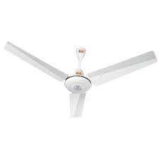

DW 6550 C

* Deep Water Fall Technology
* Shower Rinse
* Wide Impeller
* Water Level Adjuster
* **Rs 24,900**